These are the levels of learningL
These are the levels of learning
Levels
The experiences and outcomes are grouped
into 5 levels.
EARLY – the pre-school years and P1 or
later for some.
FIRST – to the end of P4, but earlier or
later for some.
SECOND – to the end of P7, but earlier or later for some.
THIRD
FOURTH
SENIOR PHASE – S4 to S6 and college or
other means of study.
The learning experiences and outcomes
can be packaged in different ways
appropriate to the individual. These are
intended to provide personalised and
varying programmes of learning so that a young person is secure at a level before moving on.
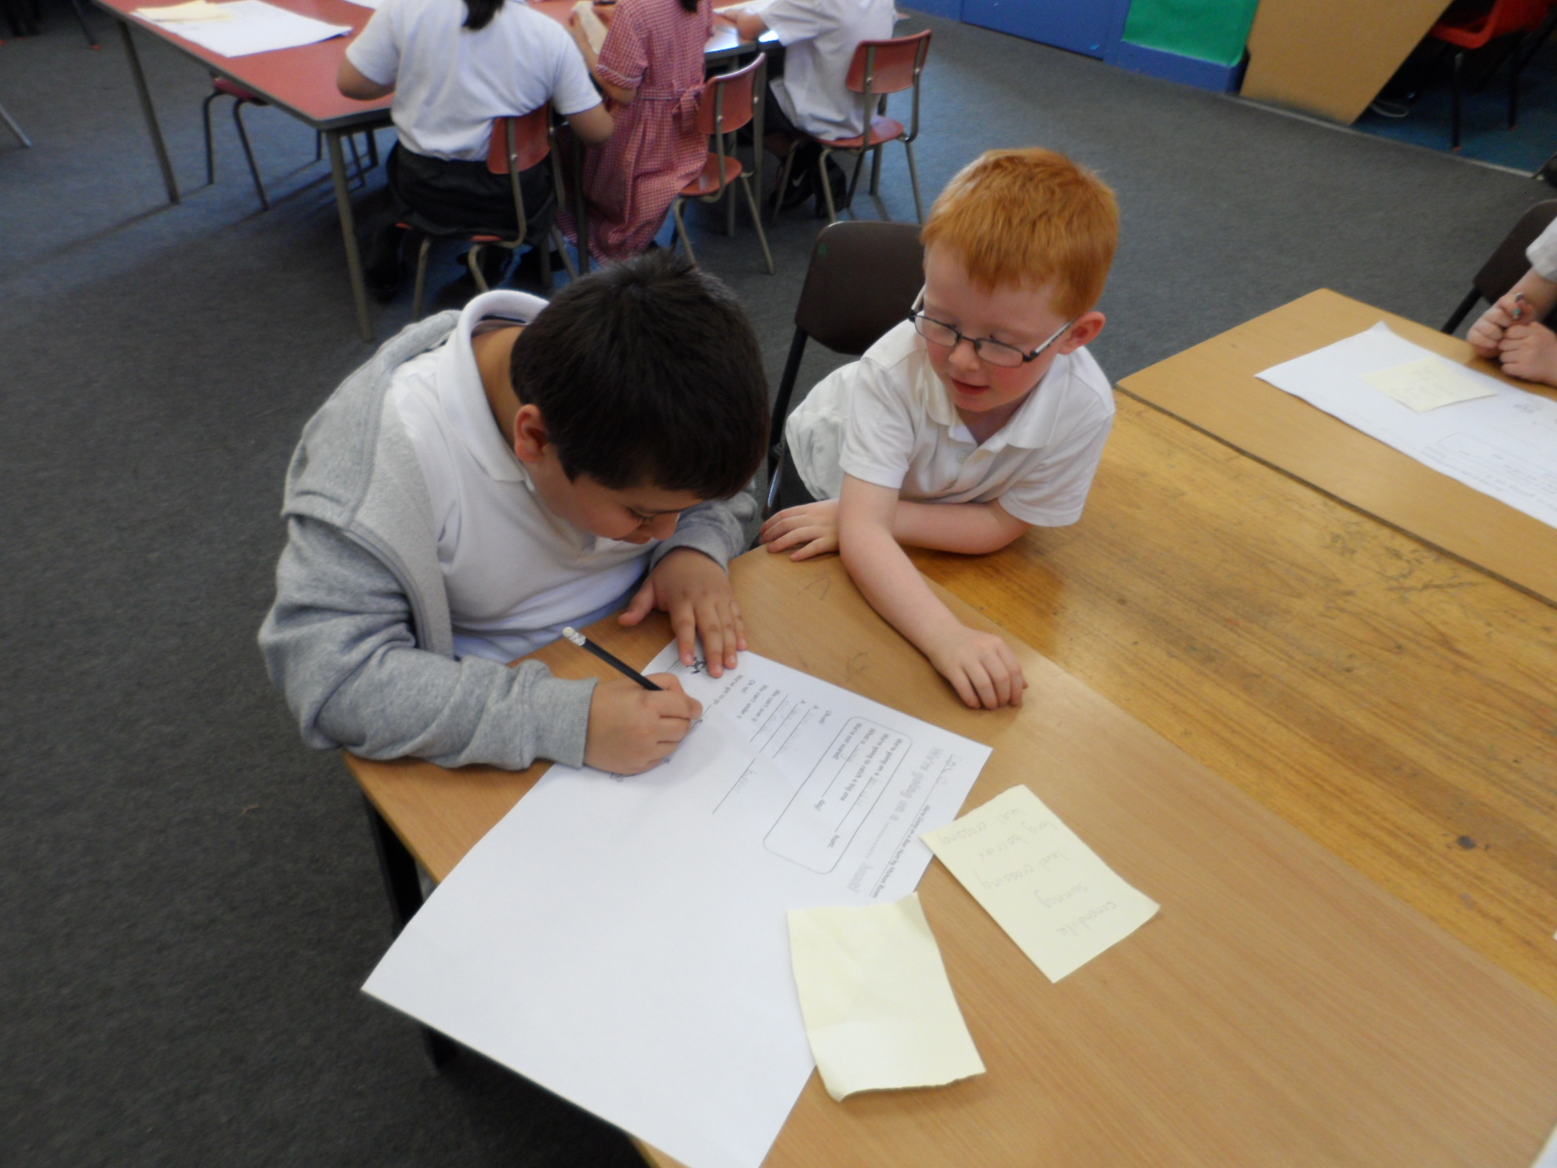
Education for Change
‘It’s all changed since I was at school.’

We all have memories of what life was like for us at school and will notice changes in our own children. In this world of new technology and growth our children sometimes have greater knowledge and skills than we have!
As times change, education and schools
have to adapt to keep up with these changes taking place in the world around us.

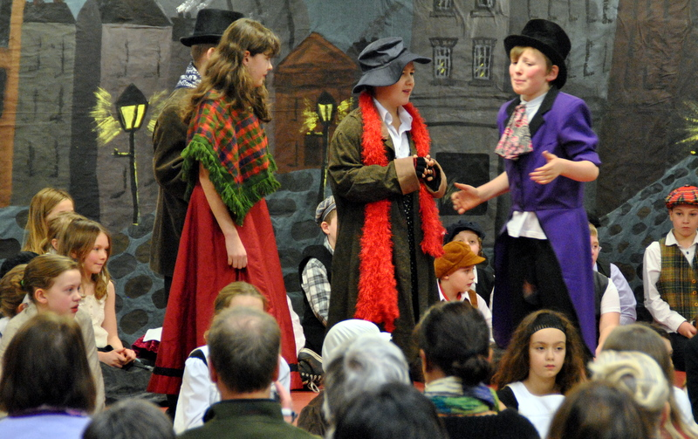

Pupils will have more responsibility for their own learning, more opportunities for personalisation and choice, and more opportunities for active and collaborative learning.
Curriculum for Excellence

The Curriculum for Excellence is a new way of looking at the curriculum that builds on best existing practices in Scottish Education.
It is a continuing process to encourage more learning through experiences to best ensure that children and young people are prepared for the complex world they will be living in.

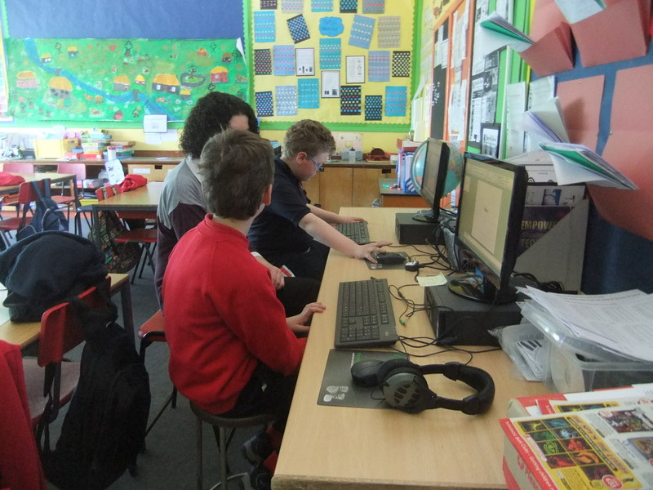

“It’s about knowing what you have learned and what you are learning now and what you need to
learn in the future”

To find out more visit
www.ltscotland.org.uk
The experiences and outcomes are grouped
into 5 levels.
EARLY – the pre-school years and P1 or
later for some.
FIRST – to the end of P4, but earlier or
later for some.
SECOND – to the end of P7, but earlier or
later for some.
THIRD
FOURTH
SENIOR PHASE – S4 to S6 and college or
other means of study.
The learning experiences and outcomes
can be packaged in different ways
approriate to the individual. These are
intended to provide personalised and
varying programmes of learning so that a
young person is secure at a level before
moving on.

